(Approx. 399 words)

Glary Utilities
Reviewed by Joe Lucchesi, Member, The TUG - MOAA User Group, Hawai’i
March 2015 issue, The TUG newsletter
www.thetug.org
editor (at) the-tug.org


Glary Utilities is a full-featured computer cleaner and optimization package, at a very low price consisting of optimization applets to keep your computer running smoothly, faster and safer. Currently there are two versions: Pro and Free.

As you can see from Figure 1 below, there are about three dozen applets within the overall package.

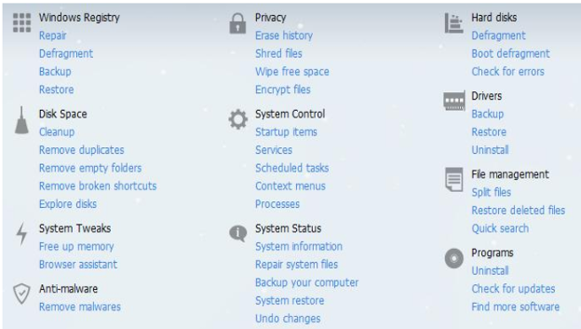
Figure 1

Everything from hard drive defrag to malware remover.

Each of these applets are available in a standalone download, but why would you want to download 30 something software programs when you can get an all-in-one, low cost program? Rhetorical question.

How low is low cost? $27.96 for a 1-year subscription and can be installed on 3 computers with the same license key. Renewals are $11.99.

With the software purchase come
- Automatic care in background
- Enhanced system fixing, Optimizing and more
- Auto clean for Privacy Security whenever you log on
- Free 24x7 Tech support
- Automatic update to the latest version and,
- Consent for Commercial use

Download either version at glarysoft.com

Here’s one review
“Glarysoft's Glary Utilities is one of the most consistently popular and most frequently recommended system utilities, and why not? It bundles some of the most useful Windows-related tools in one free download. It scans and cleans your PC, cleaning temporary files, removing junk files, fixing broken shortcuts, and resolving a wide range of issues, both major and minor, that most Windows users will have no trouble recognizing. You can configure its One-Click Maintenance option to run just those processes you want with a single click, making regular maintenance just too easy for excuses. You can run any of its many tools individually, too.”
CNET Editors' review

Upon startup of your computer, Glary tells you how long it took to boot up in minutes and seconds. You then have the option of disabling stuff that is starting that you don’t need at the moment. You can always restart them if needed.

The Registry Repair and Defrag are both fast and provide a listing of what can safely be removed.

The TUG cannot, does not, and will not promote any product or software. However, as an individual user, I highly recommend this one. Download the 60-day trial of the Pro version and see for yourself how good it is.

